Family Artifacts Can Expand Your Genealogy Story
Presented for Natchitoches Genealogical and Historical Association monthly meeting April 28, 2026 7pm by Marcy Frantom, Independent Researcher.
There are many more qualified than I am to talk about smart genealogy research in archives and libraries. I commend NGHA for creating a place where those interested in the fascinating and long history of Natchitoches Parish can help each other flourish. My family received the pleasant gift of written family research passed on by loving relatives which leaves me in a pickle. How can I do my part and add to the story?
It’s possible you might have done as much archival research as your strength could muster and yet still have an ardent desire to write something about your family line tying together those dry and crumbly dates and places. Family artifacts can help fill in some of the holes in your narrative. You don’t have to own the object to use it in your story. You can draw it in your family files, photograph it at a museum, or record yourself telling the story of that thing that affected your family so much. This is a talk about those possible things.
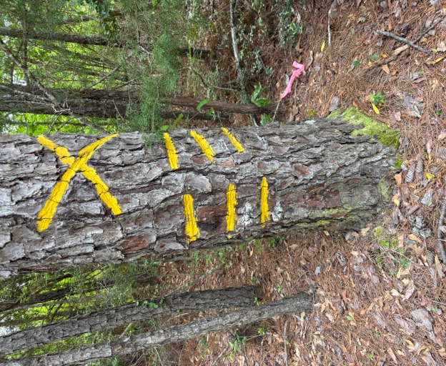
Let’s think about it another way. Surveying always interested me. It floors me that colonial people in Natchitoches could ride around on horseback, measure land with a chain, and figure out what agreed upon geographic features those measurements described. Oh, that’s a river—no it’s a stream—no it’s only active in the spring so it’s a fordoche, if you speak French. Which means it’s a brushy creek that flushes with spring water and is dry in the summer. If you’re walking in the woods and come upon a tree with marks on it—that’s a witness tree. That tree can’t ever be cut down and bears actual witness to the boundary of your land. If you look at your survey map, it might show in the margins something like “an 8” hickory tree at NW corner,” for example. This tree will be marked with an X—it’s a corner. If you have three stacked dashes, it is called an eye. It looks to the line. You could say, if you live there, it’s the boundary of your existence. It’s like your skin. Anything outside of it is someone else. Where you end and the world begins.
What does this metaphor mean in genealogy? One point of genealogy is to say this group of people I am documented are the same as me. I am telling you who we are. It’s not enough to gather the facts but you must interpret them, too. It’s going to be more interesting and useful to people. I can include things my family did that I’m proud of but what if we want to know how they saw themselves? What were their reasons and currents of their time that sculpted them into the actions of their lives? Here we enter a sort of unknowable place. We may have to gather information from many sources—not all of them from the census or tombstones.
We might want to know how our family sees itself from the perspective of descendants to understand why the family is so. We might be wrong or not have all the information. I often think about an exercise Dr. Pete Gregory gave us in Anthropology Theory class. We were asked to list our ancestors and their children. For the first time, I realized my father’s grandfather had 23 children. In fact, only a few of them were biologically his but he raised all these kids. Maybe there were even more than I know about since he lived after the Civil War when many of soldiers came home and died rather quickly. The census gives us a snapshot of the household only every 10 years. People of any means at all were given children because parents were dead, gone away or unable to keep them. So, what would the real story be—was John Frantom a saint or was he a farmer who needed free farm hands?
We can describe the way our family is presented to the world because that’s what the facts tell us. But we also can employ ourselves as witnesses to outline more privileged information. We may learn to respect someone we were told was a reprobate—or the reverse. If you’re a private person you could call it the inside and outside story. You can decide what to share—remember your interpretation affects other, too.
Let’s approach it as play. We may never know the total truth about our ancestors if they didn’t present themselves in documented form. By the time you are of any age relatives will start giving you things from the family—sometimes outsiders will do that, too. And it just snowballs until you have tons of stuff stuck to you! You don’t have to keep it. You can record it and your impressions and give it away, if you wish. It doesn’t have to be a burden.
What we are looking for—objects or whatever—that have some luminosity, something that gives insight into a relative, something you can learn from or look up the history of in a general sense, something that delights you or reminds you of some aspect of the family you’d like to pass on to your kin. Things that are worthy of being recorded in your book of your family, whether you ever write it or not.
What is this mysterious object? It could be a story. Country stories often have a moral, reveal something about the teller, and can be mined for knowledge like a text. I can think immediately of two stories my grandfather told my father. One is about a foolish man who thought he heard a ghost moaning in the cemetery, but it was really a white Hampshire hog dying of cholera that got through the unlatched gate. That sort of story could tell you grandfather was a practical man but also somewhat judgmental. We never met him as he died in the 1930s, so I don’t know. Another is the story of a murder at the Goldonna train platform my father insisted he witnessed but really happened before he was born. I found the text of the article republished by historian Gregg Davies from a dated Winnfield newspaper. I don’t think that means Dad was a liar, but that his father told him so many times and he’d visualized it so often he thought he’d seen it happen. Think about the parts of the story that get the most detail. Like ballads, they often leap and linger. In my father’s version, the wife coming out to tell the victim’s family her husband is dead gets that lingering description. She is always described as beautiful, coming out of the slab house (so called for waste board siding usually meaning a timber camp house) wiping her hands on her white apron saying, “You don’t have to wait for him anymore, he’s dead.” That honesty is shocking now but a matter of tradition as they lined up in single file to pass through the bedroom. In those days, the family of the victim would camp at your house until you gave up the aggressor or something dire happened. That was the common law. Women and children are the most sympathetic characters and maybe the emphasis on the wife was her unstated moment: isn’t it a shame what men do?
It could be a song your parents liked. My mother liked records by Mantovani, who Wikipedia says was Britain’s most successful album act before the Beatles. Mom and Dad played his records on their expensive Grundig hi-fi radio record player housed in a Danish Modern cabinet on what I guess was date night. But my father really preferred folk music such as Woody Guthrie’s “Greenback Dollar.” It’s a song about a guy loving a woman more than the American greenback the government printed to pay for the Civil War. It was a comedic comment on what the Yanks were doing—how out of touch with southern living they were. Mom was 50s glamorous with a cloud of dark hair and red lipstick; Dad was country with big hands and a boxy olive drab field cap worn at a jaunty angle I still see the rural boys of Natchitoches parish doing.
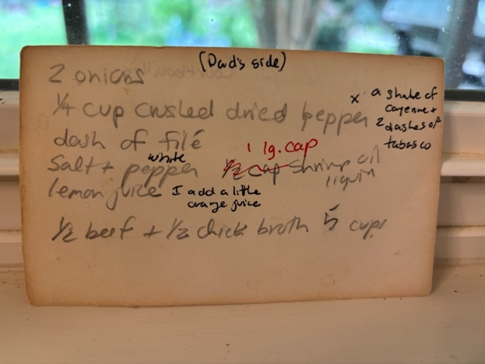
Maybe for us, my parents being so different created a wide range of acceptable behavior. It was going to have to be okay to have several “rights.” I have a good example in a recipe with Mother’s handwriting on one side for how to prepare “fish soup” and you flip it over and, on the back not to be outdone, Dad’s 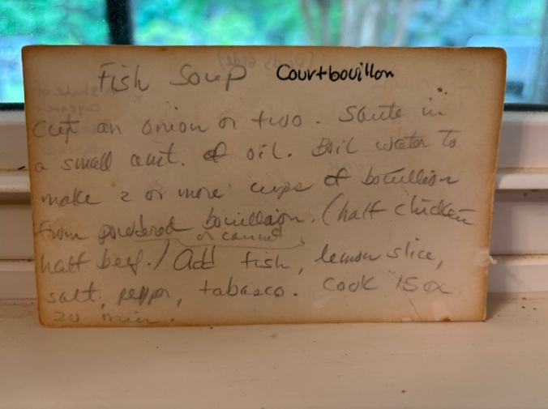country French Court-bouillon recipe as he dictated to me before I went home that night.
And if someone gives you something before they pass, it seems especially freighted. My mother gave each of us an envelope of our accomplishments she must have been proud of with an article on her great love, Creationism. She was a teacher and a witness in the Supreme Court case Edwards v. Aguillard (1987) which ruled against the Louisiana Creationism Act. The act would have allowed Louisiana teachers to teach God’s creation of the earth alongside the evolutionary model in public schools. She wanted us to remember that she was a part of that. Dad and I shared books, and he’d turn page corners down for things he liked for us to discuss. So, his representative objects might be the 1908 Big Game at Sea book by Charles Holder, here showing a giant octopus in the Pacific, and a length of quality braided rope he twisted into a circle and kept on his nightstand. As a farmer and sailor, he knew the value of good rope. I believe it meant the Masonic Cable Tow, symbol of mutual aid to others and promise of sharing your wisdom, as a secret symbol of the fraternal organization my mother forbade him to practice. Apparently, she relented in the end because she saved it and gave it to me.
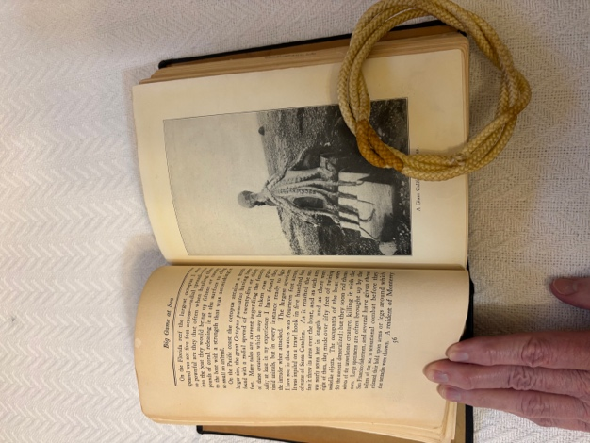
There’s no right answer. You can recall conversations you had with deceased relatives (did you remember to write it down?) and check your interpretation. Try to thread the needle with your available facts. You can always ask your living relatives and make sure you’re not too far off base.
Why were people named as they were? Nicknames?
Games you played. Will anyone in the future understand why we were so enamored with sister Penny’s “Six Finger” gun without knowing about Cold War spies? A relative from Bellwood told me they played a game called “Poor Jack” where you take a coal from the fire and place it on a wooden roof shingle and try to pass it all the way around the family sitting at the fireplace, each one holding the shingle briefly, until the coal either died or fell off. Would you know what it is if you found an old shingle in the house? Was it a morality play for the shortness of life? Or just a lack of toys?
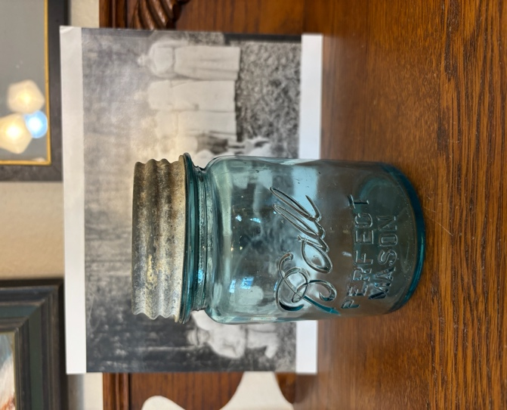
Things you couldn’t know until someone told you. I thought my grandmother had her hands full as a homemaker for 7 kids until a woman from Wyoming brought me a lovely blue canning jar with an aluminum lid and told me my grandmother had a home canning business going in halves with her grandmother! I dug into the history and found out canning was part of the Natchitoches Parish Extension Service community instruction starting in the early 1900s so people could stretch their food sources and that, just like school bus drivers, rural folks could list the extension service agents in order of their service. They were just that important in their communities.
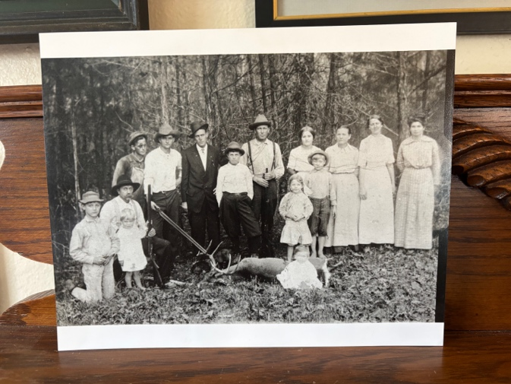
Here’s her community—my grandmother, Mamie Dell Jones Frantom, is on the far right. My grandfather, Jehu Preston Frantom, is kneeling with the deer and my father, Isom Frantom, is beside him with the wheat blond hair and weird hat. What was the photo about? This is from a postcard made by an itinerant photographer. So that event (a special visitor to the Point) but also, I’m told, it commemorates the last deer killed in our part of the parish as hunting was outlawed in 1915 due to folks killing off all the deer. My grandfather was a professional hunting guide and sold cured deer hams to timber workers. Outlawing hunting was going to change their livelihood. You can draw maps of your family neighborhood if you have information on that and gather important information of all kinds at the same time.
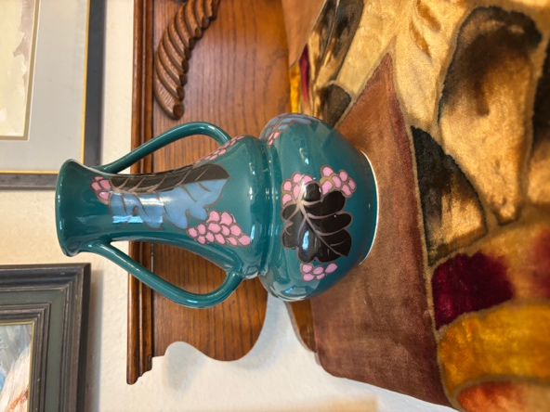
And some things that are just flat wrong but for emotional reasons, just right. Our mother’s grandmother, Marie Eloise Morrison, was a performer in the Grange, a rural civic organization. In fact, April is the Grange Month. She played violin, sang and juggled Indian pins. She contracted TB while her children, one of them my grandmother, were still young and she lived in a tent in the front yard until she died at age 24 in 1905. We have one nice photo of her sitting at a table with a fringed velvet hand-painted cloth and a vase of flowers. My mother’s sister gave me what she claimed was the vase and cloth. However, it can’t be the actual items because the cloth is machine stitched and the vase is printed “Made in Japan” which wasn’t required by law until 1921 when it changed from “Nippon.” The story of Marie Eloise, a talented artist and mother who refused to leave her children and go to the tuberculosis sanitarium, is a compelling story and must have propelled my aunt to make actual having something from the life of her grandmother.
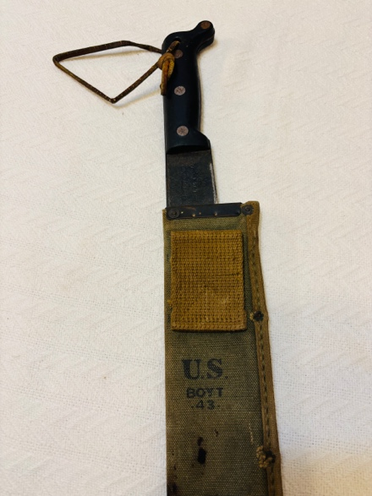
We also have several things from the men. As women, we might have to dig deeply here to figure out what they are and what they mean to men. This is a sharp machete from WW2 where Uncle Carl Hemperley served in the Philippine Theatre in the Sightseeing 6th Army. The infantry used these machetes to hack through the jungle to create roads for the caisson movements made of beautiful first growth mahogany boards entrepreneurs after the war picked up and turned into flooring for fine houses. This one is dated 1943 and has a loop for your belt and a knob on the handle for a sure grip. It smells like my childhood memory of the scents of these military men--honing oil and dry canvas. You can study military metals and patches. An interesting war item is a New Testament jacketed in steel popularly called a Heart Shield Bible. There are illegible uplifting messages on the front in worn gold letters; Carl Hemperley carried it in his uniform breast pocket. It, along with other memorabilia and correspondence, shows he valued and kept those veteran relationships alive throughout his whole life. He corresponded with them; he visited them in far flung states. He’d always struck me as a lonely man but in fact he must have just been far from his comrades.
My father’s niece, Vicki Etheridge Lyons, just gave me a small notebook that comprises a sort of military service conversation between my father and his mother, the subject of the canning enterprise, about his deceased brother, McCoy Frantom. McCoy died in the Panama Canal before WW2 began employed to test a new anti-aircraft gun and Dad went there during his tour of duty to find out what really happened. They thought he was getting well and suddenly he arrived in a pine box on the train. Writing in the notebook, Dad kept a diary of the trip so she could be with him in spirit. The notebook doesn’t address McCoy as if he were a subject too painful to bear. Dad writes Nov. 2, 1944: “Going through canal. Not a gift Mama, just something to carry with you to remind you of me sometimes.” She responds Nov. 23 with a list of who came to Thanksgiving dinner and reported they had all gone to the Sanders Chapel to mark (perhaps McCoy’s grave) and put flowers on graves. She says, “Isom (my father’s name) sent small but precious gifts. I liked them all.”
Dad’s mother gave me a Rosenthal coffee set my father bought in Europe in WW2. I’m not sure city people know what a luxury coffee is to country people, but I know having china anything was a status symbol after the War. I remember in Kurt Vonnegut’s novel Slaughterhouse Five one of the men is executed for stealing a German teapot. Grandmother also gave us an incomplete set of stainless silverware with the initials USN engraved on the handles—U.S. Navy--that Dad or his brother might have sent back to her. She was proud of her boys.
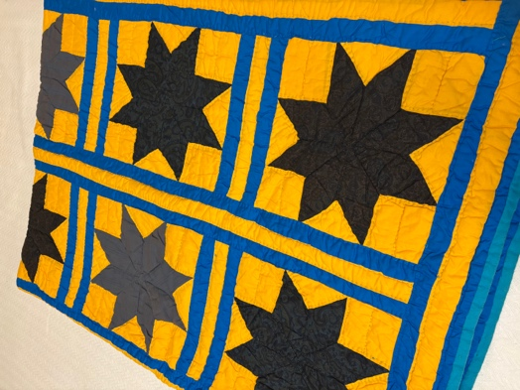
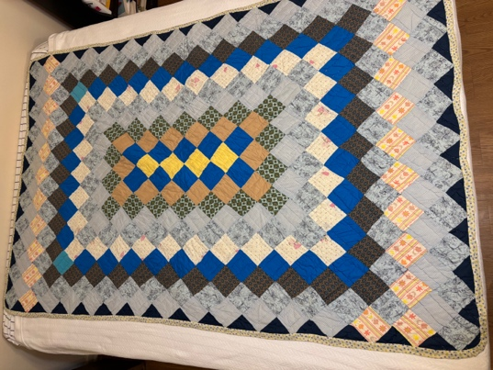
Dad’s mother gave each of us girls a “Round the World” quilt that represented her boys who had gone around the world in the military, she said. Notice the bottom pink row has an extra square customary in quilt making as it breaks the pattern and inserts a humble notion of imperfection as only God is perfect. She made Dad a “LeMoine Star” quilt that came from the LeMoines of her community. Maybe the message for Dad was “don’t forget what we taught you at home.” The 8-pointed star is unusual, and its history could probably be studied. The blue bars are kind of overwhelming, but I found out they were added when grandmother found out my parents had a queen size rather than a traditional full size bed. She already had those hard star squares done and expanded the borders rather than make more squares. Notice the darkness of the stars--they were made from her mourning clothes.
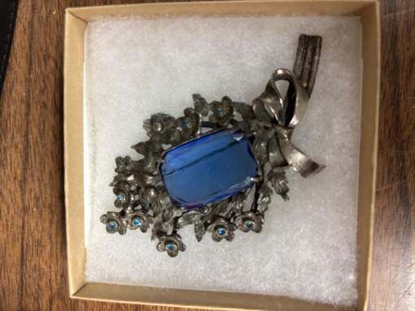
Grandmother Frantom also gave me a brooch, the only one I remember her having, that is not expensive but has blue rhinestones, blue like her eyes, in an ebonized pot metal appropriate for a widow. Queen Victoria was the “patron saint” of widows as she mourned Prince Albert all her life.
Grandmother’s greatest possession was not a thing but her ability to choose who she voted for, and she made it a dressed up all-day affair. We drove her to town, she visited her friends, went to the polling place to vote, and called us to pick her up when she was done luxuriating.
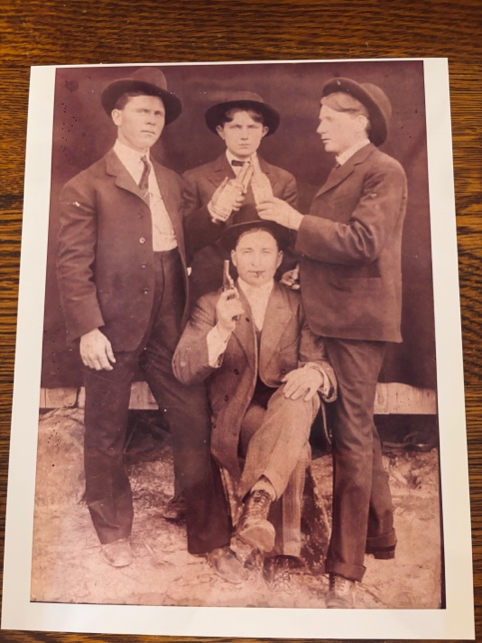
Photography is an obvious choice because there’s so much information to read in them. I spoke about itinerant photographers who traveled from farm to farm. I would say this must have been a big thing in the early part of the 20th century. Many families have these early photograph-postcards that had preprinted postcard information on back and the local photo on the front. It must have been a new technology that allowed customers to get the product and collect the fee before the photographer left town. Here’s proof people have always been turned on by comedy shots: the Golden boys of Goldonna ham it up with boozy bottles and a wooden pistol. Notice the house boards show below the lower edge of the tarp behind them, probably whitewashed. I love looking for things they might not have meant to show.
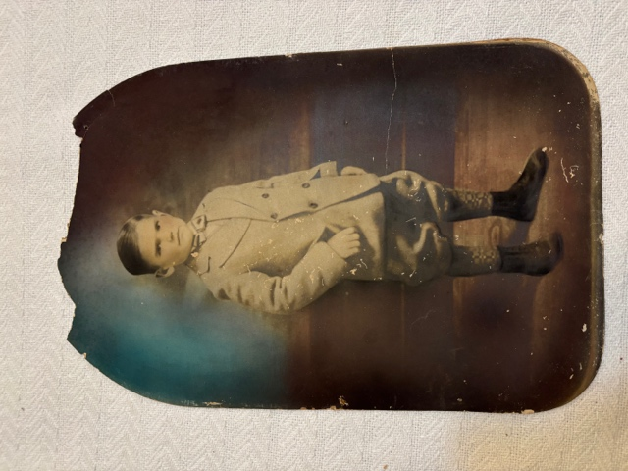
In the history of photography, tintypes came first but I don’t see many of them in out in the rural parish. Later, large format glass negatives with silver halide gelatin painted on them were popular and convenient for outside exposures where the photographer had more available light. Next, large format hand painted and colorized portraits hit the scene that are lovely and tell us more about the colors in their world. This photo is a studio picture designed to stand in a swinging wood frame resting on the top of parlor furniture. Carl’s uncle as a boy in black and white is colorized in a unique cathedral curved top shape that was patented and the print pressed in the round to look 3-dimensional and fit into a curved glass frame. Already, people desired a convincing likeness.
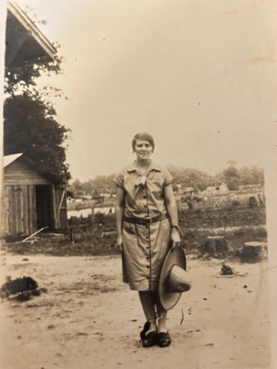
When personal cameras were manufactured at a reasonable cost, Louisianans took lots of home photos showing their “real world” like this one with Carl’s sister, Myrtle, in their scraped yard holding a sombrero and standing on her shoes for some reason. I love the tree stumps in the background—that was 1930s landscape because the Great Forest was being cut down and hauled out by railroad. Sometimes you’ll see free range hogs standing in the yard.
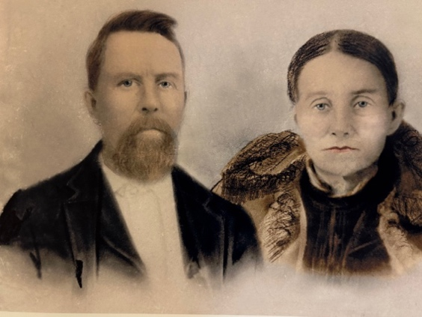
Your subject’s clothing can be “read” or dated. In fact, I think a couple of the genealogy sites will do this for a fee. This photo is of my Uncle Billy and his wife presumed to be taken in a studio after the Civil War. An internet professional read the clothing and told me the styles were pre-Civil War era and showed how little anyone could afford to have new things after the War. I love that you can see they had blue eyes.

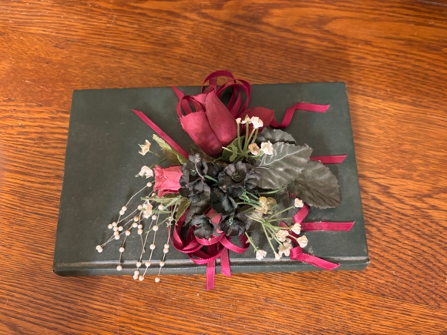
Sometimes you’ll find precious family books kept in places of honor that are not the Bible with its important list of family trees. This one is a copy of the John G. Belisle’s History of Sabine Parish owned by Anna Richey that was of such great value to the family she created a posey and glued it to the book. Another such in my area is Briley’s Winn Parish. These give the family context of relatives in the area and their prized place in the larger community. I would say such books overlap with the published histories of churches and your interviews of knowledgeable attendees at cemetery homecomings who can give an oral history of the area. A history of Bienville Parish by Billy Jean Poulan is another such book. Our book on the WW2 soldiers of Natchitoches Parish is another.
I know we tend to think of family genealogies as separate from other memorabilia we have from the family, but we don’t have to do that. I’d recommend capturing your thoughts on paper, computer, vocal notes or whatever you’re comfortable with because our thoughts and the connections we make are often fugitive. These connections and “a-ha” moments are a great gift to our descendants and siblings—and ultimately, to our future selves who may not have the time, courage or energy to pull it together. We can be witness for our generation and inject some colorful interpretations into our family story.

